Homework 10

Atiq Patel CWID: 10432883

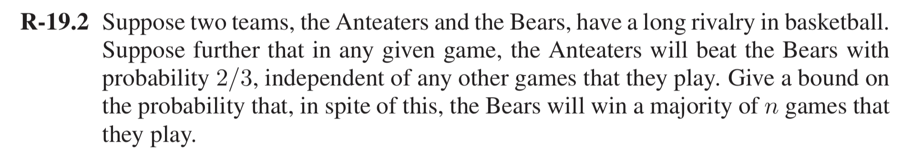**Solution:** We know that the independent probability that Anteater would win= 2/3

Then the Independent probability that Anteater would lose =1/3

Let us assume Xi be the random independent trials for Games that are selected, Then

= which is in turn

.

Consider be the mean probability of each independent event. Thus,

Using the Chernoff’s bound, we get

We know that for Bears to win, they have to win at least 50% of their games. Thus, Win = 0.5n

Substituting the values, we get

Thus, the bound on the probability that the Bears will win a majority of n games is <0.898n

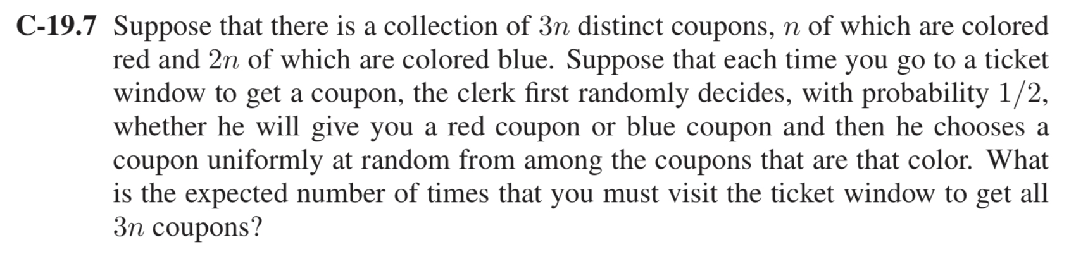

**Solution:** One way we can solve the problem is by using two-coupon collector method.

Consider random variable X which represents number of time that we must visit the ticket window to get n coupons, we get

X=X1 + X2 + X3….Xn

Where Xi stands for the number of trips we must visit to the window to get I -1 distinct coupons to have i distinct coupons.

Hn stands for the number of times that we must visit the ticket window to get at least one instance. Thus, for n instances it will be, nHn.

Let us consider that both of the tickets are distributed in two separate windows. Since we haven red colored coupons and 2n Blue colored coupon, we require nHn visits to red window and 2nH2n visits to blue to get 3n coupon tickets.

The probability of getting a red coupon or a blue coupon =

Probability of getting distinct blue coupon

Probability of getting distinct red coupons

By linearity of expectation for red coupons,

E[X] = E[X1] + E[X2] + … + E[Xn]

E[X] = + + … +

E[X] = + + …. +

E[X] = n

E[X] = 2n Hn

By linearity of expectation for blue coupons,

E[X] = E[X1] + E[X2] + … + E[Xn]

E[X] = + + … +

E[X] = + + …. +

E[X] = 2n

E[X] = 4n H2n

where Hn stands for nth Harmonic number which can be approximated as ln(n) < Hn <ln(n+1).

Therefore, expected number of visits to get blue coupons are = 4nH2n

But the probability of getting a red coupon is also = , the estimated number of red coupons would be 2nH2n.

Since, nHn <2nH2n we would receive enough red coupon tickets to get all n trips. Hence, the expected number to get all 3n tickets are **4nH2n**.

The run time would be O (n log n).

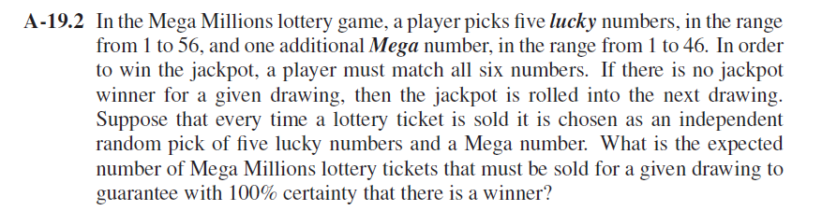

**Solution:** One way we can solve the problem is by using two-coupon collector method.

Consider random variable X which represents number of times that we must visit the ticket window to get n lucky numbers, we get

X=X1 + X2 + X3….Xn

Where Xi stands for the number of trips we must visit to the window to get i -1 distinct numbers to have i distinct numbers.

So, the total number of possible we can get from five lucky number from a pool ranging from 1 to 56 and 1 from Mega ball ranging 1 to 46 is

Let us consider this number as n…

By, linearity of expectation, we get

E[X] = E[X1] + E[X2] + … + E[Xn]

E[X] = + + … +

E[X] = + + …. +

E[X] = n

E[X] = n Hn

where Hn stands for nth Harmonic number which can be approximated as ln(n) < Hn <ln(n+1) and also for the number of times that we must visit the ticket window and grab at least one number. Thus, for n instances it will be, n Hn.

Thus, the expected number of Mega Millions lottery tickets that must be sold to guarantee with 100% certainty that there is a winner is **nHn**.

The run time would be O (n log n).

Considering all the tickets are distinct

Here for a person to win the jackpot, He selects five numbers from the range 1 to 56 which is equal to 56C5 =

And the possibility to select all the Mega balls from 1 to 46 are

46C1

So, the total possibilities of selecting five numbers from the range and one number from Mega balls = 56C5 * 46C1

So, the expected number that must be sold in order to guarantee a winner is .